**System process**

Having identified and described the components of WSSA, it may be necessary to show the overall

processes for the system

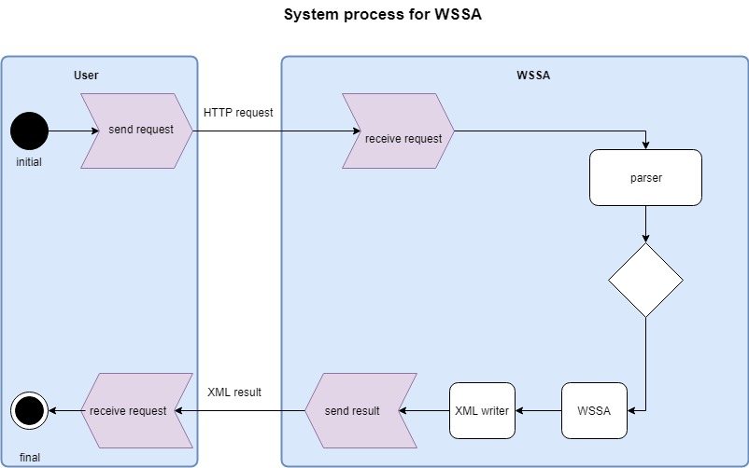

Fig.overall system activity diagram

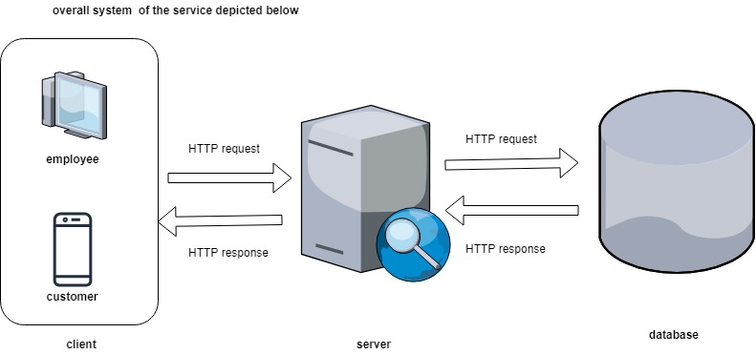

Fig.overall system service

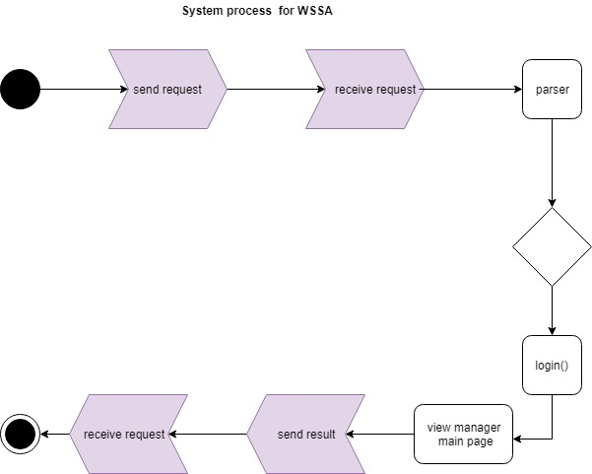

Fig.overall system activity diagram for manager

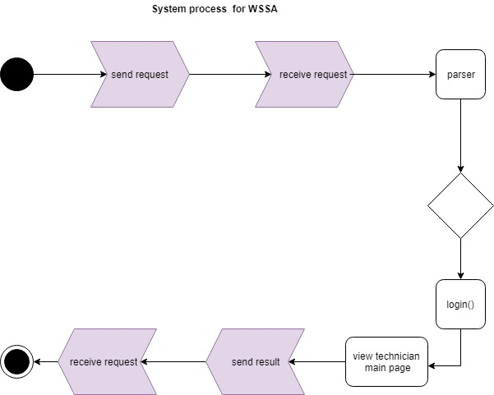

Fig.overall system activity diagram for technician

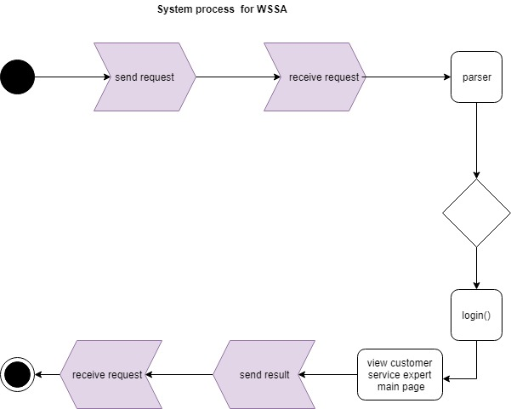

Fig.overall system activity diagram for customer service expert

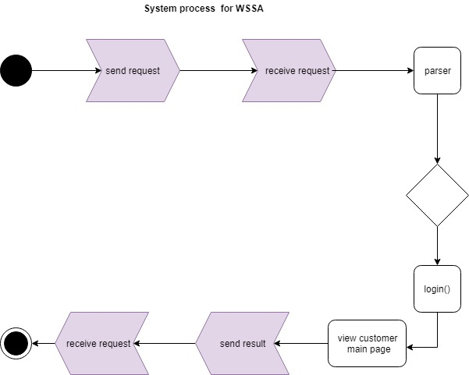

Fig.overall system activity diagram for customer

Deployment diagram

Deployment modeling is used to show the hardware of the system, the software that is installed in the hardware and also shows how the software and the hardware components work together. Deployment diagrams are used to visualize the topology of the physical components of a system,

where the software components are deployed. And used to describe the static deployment view

of a system. Component diagrams and deployment diagrams are closely related. Component

diagrams are used to describe the components and deployment diagrams shows how they are

deployed in hardware.

The purpose of deployment diagrams can be described as:

* Visualize the hardware topology of a system.
* Describe the hardware components used to deploy software components.
* Describe the runtime processing nodes.

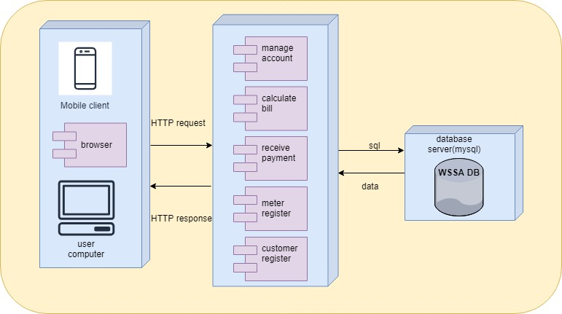

Fig.deployment diagram